User manual
Thank you for purchasing my equipment!
If you have any questions - please write to me: vostokelectronics@gmail.com
This transponder is compatible with Vostok timing system only.

After each Vostok decoder turning on, you must “register” this transponder on decoder for faster recognition. When registering transponder, please keep transponder to the detection loop as close as possible, and wait decoder’s “beep” After this, decoder detects this transponder from higher distance/speed from the loop.
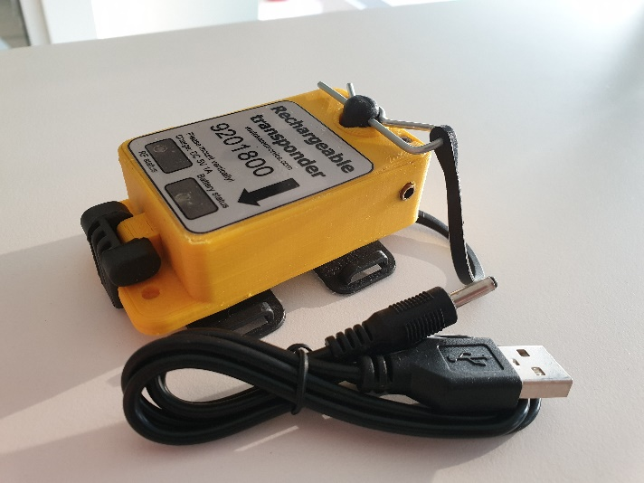
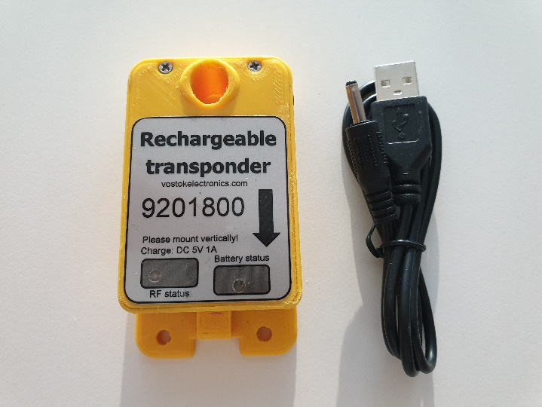
Do not mount transponder horizontally! Full transmitting power is on transponder bottom. Please install the transponder so that the arrow points to the loop. It is preferable to mount the transponder about ~30cm above the detection loop, with no metal or carbon fiber between it. Make sure the transponder can not get detached during a race. This transponder fits to Mylaps transponder holder.

When transponder is enabled, you must see blinking green LED.
To turn on transponder you must use M2.5x10 screw. Please do not overtight!
When transponder is charging you must see blinking red/blue LED simultaneously.
When transponder is charged you see solid blue LED
If your transponder has issues with batteries, you see red LED.
Transponder charging plug 3.5/1.3mm (power cord for charging from USB port is included)
Transponder charge power: 5V, up to 1A DC.
Dimensions: 70x40x20 mm
Transponder weight: ~78 g
Working time (when transponder is full charged): ~40 hours
Transponder holder is not included!
Best regards,
Andrius

