User manual
In first, thank you for purchasing my equipment!
If you have any questions - please write to me: vostokelectronics@gmail.com
This transponder works with Vostok lap timing system only.

After each Vostok decoder power up, you must “register” this transponder on decoder for faster recognition.
When registering transponder, please keep transponder to the detection loop as close as possible, and wait decoder’s “beep” After this, decoder detects this transponder from higher distance/speed from the loop.
Transponder power: 6-12V, up to 25mA DC.
Transponders works and from lower voltage, but not radiate at full power, so at higher speed/ distance to loop, you can miss your laps.
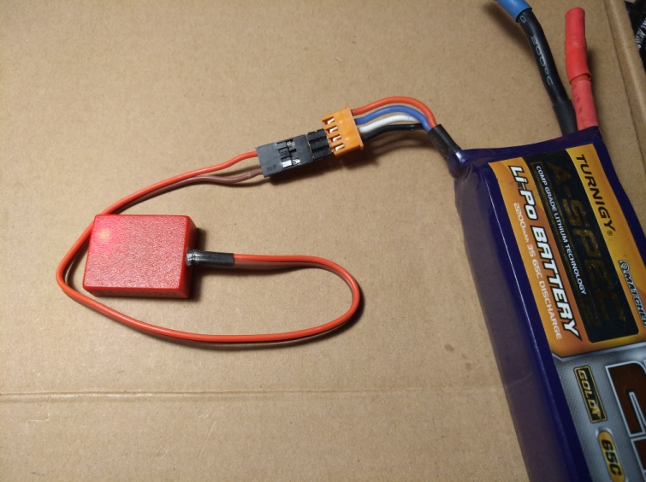
I recommended power these transponders from LiPo balancing connector.
Do not mount transponder vertically! Full transmitting power is on flat sides ( transponder mounted horizontally). It is preferable to mount the transponder as close as possible to the detection loop, with no metal or carbon fiber between it. Make sure the transponder can not get detached during a race.
When transponder is connected to a power source, you must see blinking red LED.
If you wrongly connect power polarity, transponder not burns, just not works.
Red cord is “+” brown cord is “-“.
Best regards,
Andrius

