Vostokelectronics
Lap Timing System

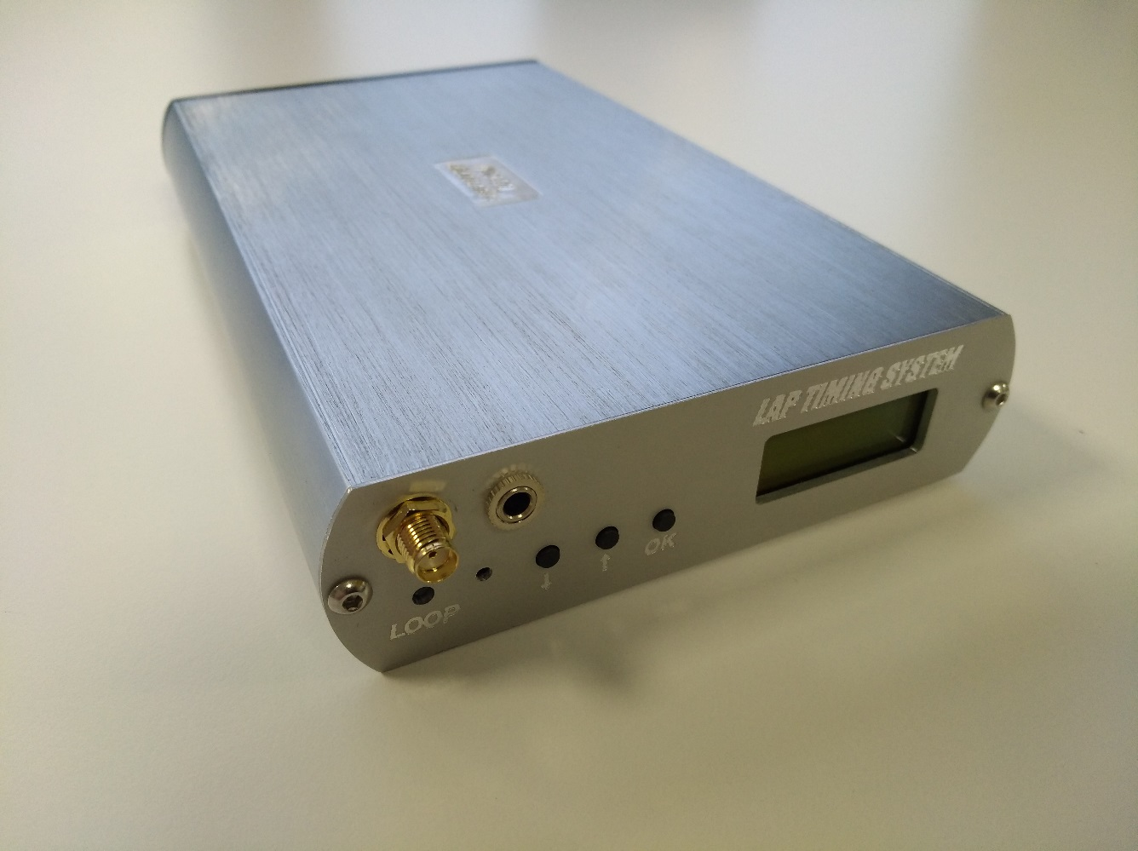

Contents
Introduction
1.Timing system
2. System installation
3. Decoder operation guideline
4. Technical specifications
5. Menu options explanation
6. Physical configuration explanation
7. FastEthernet and port configuration
8. Wifi interface module
9. Virtual COM Mode
10. Warranty

Introduction
Hello, our customer! Thank you to believe in us and our Timing system. If you have any questions – ask us: vostokelectronics@gmail.com
This timing system works with many transponders: MRT, AMB DP, Mylaps RC3; MylapsRC4 hybrid, our club transponders, and many others which use the same coding system.
Supported and tested scoring software: RCGarage, Laps Free (only through USB), Zround, Flip Side racing, RCM, RC-Timing, RCSP, Live time (with 10sec delay on start).
Minimum lap time - ~3.2 seconds. Please check approximate your lap time, if you use very short track, before order our system.
„AMM converter“ Android application (you can find it on the Google Play) let‘s direct receive data (through Wifi) from decoder to your Android smartphone or tablet. This is very comfortable for persponal training or for small fun race with friends.
Most of timing decoders are compatitible only with manufacturers brand transponders. So, the idea of making a universal decoder was born. Basic schematic and firmware were found at open sources on Internet. Decoder has following features:
- FastEthernet interface
- Wifi interface
- RS232 support
- Audio out for headphones
- Any polarity, any 7-12V 2A power source for all conditions.
- We produce very sensitive signal amplifier, which allows to use loop up to 2x18m (36m) long, especially for boat modelers
This timing system does not work with Mylaps RC4 transponders.
Timing system detecting cycle is about 3 seconds. This decoder is not locked for one manufacturer, decoder can read multiple transponders, and „valid“ is any compatible transponder ID, which repeats 3 and more times during one cycle.
Vostok electronics lap timing system is non-professional, designed for small/medium events or private use. Timing system works fine with 97-98% above mentioned transponders. After long testing period, we have 2-3% of transponders which didn’t work for unknown reasons. So, if you use this Timing system for the event, please have few spare working transponders.
System is designed for the timing and scoring an RC models/karts events. The signal from each transponder in the RC model/kart is caught by the detection loop installed on the track surface or above water (for RC boat models). The loop is connected via “black box” to decoder. Decoder timestamps receives transponder signals and sends this data to connected computer. Each transponder has a unique number, which enables decoder to identify RC model/go-kart on the track.
Lap counting software will display the number of hits after transponder was hitting the loop, a very low number of hits may result that RC model/Kart may not be caught by decoder or may lead to the phantom passing's (known as ghosting). Many factors can affect the amount of hits including, RC model/Kart speed, width and high of the loop, condition of cable, transponder mounting.
System uses a single frequency, and transponders do not emit a signal continually. Instead, hundreds of digital transmissions are sent every second with a random time gap between them, the transmission will include the transponders unique id and other parameters. If two cars pass over the loop at the same time and transmit at the same time then both RC model/kart will be count, because of the random delay the next transmissions will take place at different times allowing the signals to be processed. Signal strength, hits, and noise level (background interference) are all shown on the terminal/Lap counting software.
1.Timing system

Picture from Internet
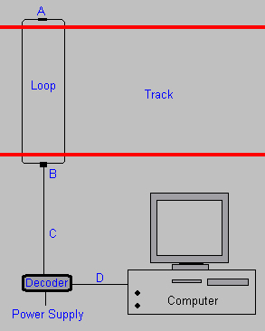

A: Terminating resistor
B: Baloon
C: Coax Cable
D: USB or FastEthernet cable. You can also read data via Wifi or use old RS232 interface*.
*RS232(COM port) is preset on board, but you must make your own cable. Cable/connection port is not included, because new PC don‘t have RS232 ports.
Power supply can be any 7-12V 2A AC/DC power supply.

System components:

1. Decoder
2. 2x5m detection loop with termination resistor
3. Termination resistor with short 2x30cm cables, for your own loop (for rc boat racers)
4. 8m coaxial cable
5. ~220V-12 VDC adapter for decoder. You can always use your AC/DC any polarity 7-12V 2A adapter for power
6. VDC connection cable for decoder power from car 12V plug
7. VDC connection cable with free ends for decoder power from battery (you can use 2S-3S LiPo or 12V Pb battery)
8. Ethernet connection cable; USB connection cable.
9. USB flash/CD with user manual, drivers, and other third party free lap timing software.

!!! Important! For lower noises and better sensitivity we always recomend to use power from battery.

2. System installation

To get started with Timing system, you need to install a detection loop, connect the decoder to PC and detection loop and mount your transponders on the RC models/karts. For optimal results, please follow the instructions in the following paragraphs carefully.

2.1 Detection loop installation

1. Make sure RC models/karts are always passing detection loop. Extend the detection loop outside the track if necessary.
2. The detection loop can be used for a track with a maximum 18 m width (66 ft).
3. For RC models track cut the slots in the track a maximum of 2 cm (3/4 inch) deep and 50-100 cm (2-3 ft) wide between the loop wires. For RC models boats, please mount a loop about 40-50 cm above water and 50-100cm wide between the loop wires.
4. For real 1:1 motocross / go-karts / car track loop must have 90-120 cm (3-4 ft) wide between the loop wires.

Installation of the detection loop wires and cabling

1. Make sure the slots are clean and dry. This will ensure a perfect seal when the silicone is applied after installation of the wiring. Put the wires of the detection loop in the slots and cut the excess length of the detection loop wires.
2. When all wires are installed, put the heat shrinkage sleeve over a detection loop wire end. Then solder the loop wire end to the short wire end of the connection box. When soldering the wires together, the solder should flow through the entire connection and not only around it. Now put the piece of heat-shrink tube over soldered connection and hold it over a heat source to shrink the tube (see the drawing on the next page). Repeat this procedure for the second wire end of the detection loop.
3. Fill the slot with silicone. Make sure not to overfill the slots and that the silicone is fully under the surface of the track, otherwise tires may pull out the silicone. If any silicone spills out of the slot, remove the excess silicone by scraping the top with a small piece of cardboard. This also ensures that the silicone is pressed into the slot and into the sides of the slot to ensure a perfect seal.
4. In case of an OFF-ROAD track, cover the loop with carpet or something similar. The carpet can then be covered with sand. Please be aware of the max. distance of 15 cm/6” between the transponder and the detection loop.

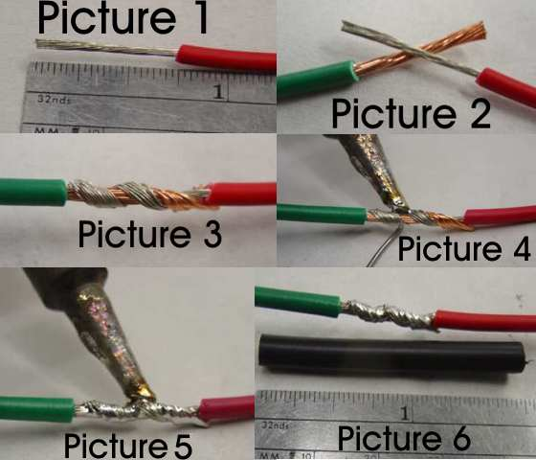

5. The detection loop is sensitive to interference, sometimes emitted by nearby cables. When possible, keep other cables 5 m (15 ft) away. Also make sure cars on other sectors of the track will not get closer than 5 m (15 ft) to detection loop, to avoid false inputs.
!!!Important! For best result please install detection loop at slowest track sector (for example after sharp turn).

Testing the detection loop installation

Once the loop has been installed, it should be tested to ensure that it is functioning correctly. We also recommend to repeat the same procedure at the start of each race event. You can determine if your loop is functioning correctly by doing the following tests:
a) Connect the detection loop to decoder and computer running timing/terminal software. Check the background noise, which is updated every two seconds in the Track Timing software. The background noise level should be between 0 and 20 points. A higher value may indicate a bad loop installation or interference by other electrical equipment in the area. Try switching off any suspected equipment or removing nearby objects and check for improvements. Short - wave radio transmitters may cause an increased background noise, especially at night.
b) The hit rate may vary depending on the speed of the transponder passings (slower passings yield higher hit counts), but for static signal you must see more than 60 hits.

!!! Important! Please keep in mind that since a bridge has a larger distance between detection loop and passing transponder, this results a weaker signal for decoder. At dawn and at night the interference from short-wave radio signals intensifies strongly and may occasionally cause transponder signals to get overwhelmed by the interference. To avoid this, keep the loop as short and low as possible.

2.2 Installation of the decoder

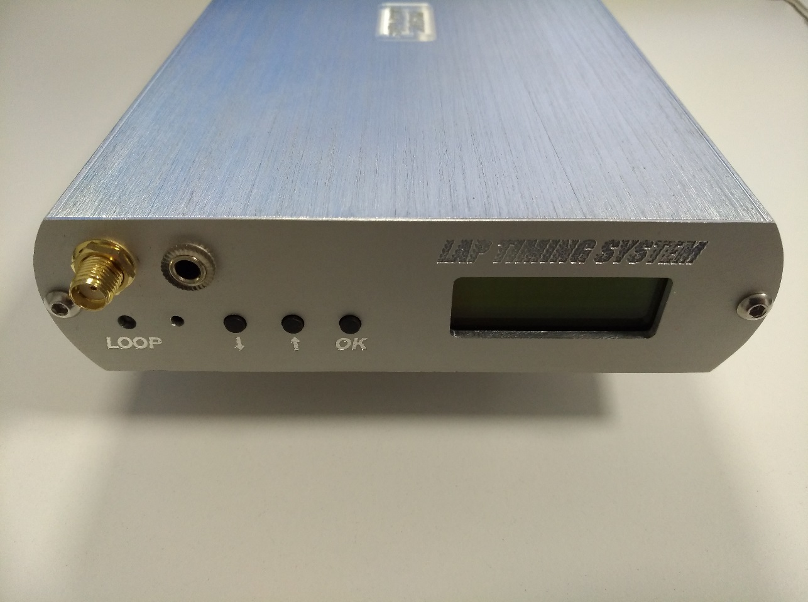

Headphones out

Wifi antenna

Loop pass LED

Status display
Menu buttons
Firmware upgrade button

The decoder is a precision and very sensitive equipment. Although it is designed to withstand shocks, please handle it carefully and keep decoder out of direct sunlight and avoid high humidity. Take special precautions in case of thunderstorms by disconnecting all cables (coax and mains) from decoder. Nearby lightning strikes may damage decoder.

- Connect detection loop by connecting 75 Ohm double shielded coax cable to decoder. Keep the coax cable at least 30 cm (1 ft) away from other cables to avoid interference.
- Connect USB/FastEthernet/RS232 serial cable between decoder and computer. If your PC does not automatically recognize USB drivers, you will find them in USB flash/CD.
- The Wifi connection: If you want, you can use Wifi connection. Using this method, your decoder does not have any physical contact to PC. The best way to power the decoder is a battery. This way of power supply guarantees least interference possibility. You can also use a Wifi connection between any Android device and decoder to see Your practice day results. (Special App needed).
- Connect the headphone. A beep will sound for every transponder passing providing an easy monitoring of proper operation of the whole lap timing system.
- Connect power adapter/wire to decoder and a power outlet. Since a power interruption will result in a failure of the timing and scoring system, connecting 12 VDC adapter to main through a UPS (Uninterruptible Power Supply) is recommended. We always recomend to use power from battery.

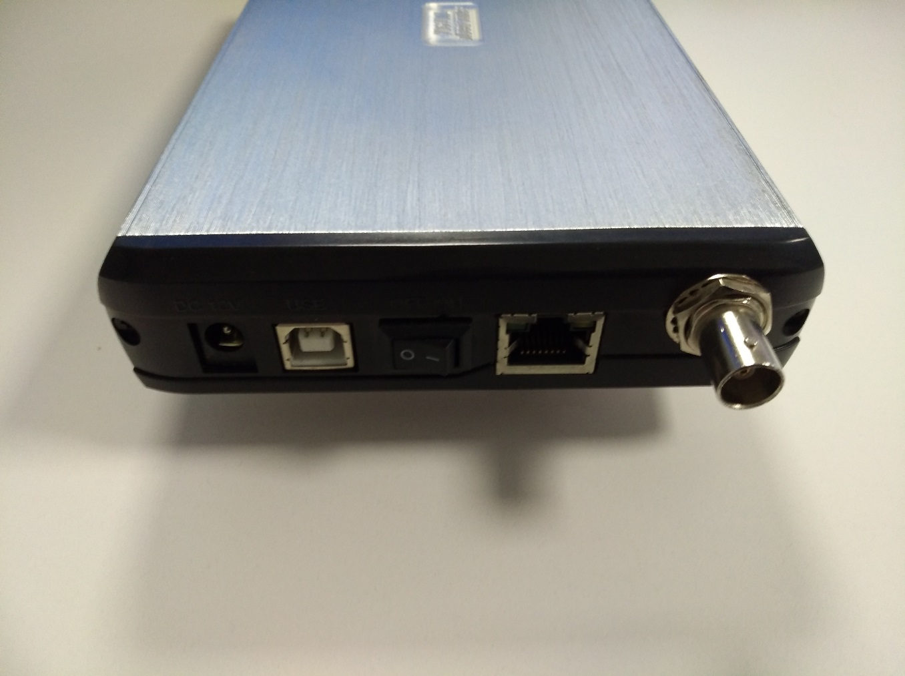

ON/OFF switch
Power input
Loop coaxial
input

FastEthernet
interface
USB interface

!!!Important! A metal timekeeping building can cause the system to pick up more interference via the coax cabling, which can result an increased background noise.

2.3 Installation of transponder

1. The transponder must be mounted horizontally (flat). The position of transponder must be identical in all RC model cars competing in the race for best finish accuracy.
2. Transponders must be positioned near to loop side, with no metal or carbon fiber between transponder and detection loop.
3. Fix transponder to the model with the help of double-sided adhesive tape or nuts and bolt. Make sure transponder can’t get loose during the race.
4. The transponder must be mounted horizontally on the kart, preferably inside the right side pot, with the fixing pin pointing upwards or downwards. The position of transponder must be identical on all karts competing in race. Transponders may not be placed higher than 15 cm / 6’’ above the track, with no metal or carbon fiber between transponder and detecting loop.
Transponder holders are permanently fixed on the kart using tie - wraps or 3M double sided tape (on smooth surfaces only). Make sure the transponder and transponder holder can not get lose during a race.
5. Connect the power plug to a free servo channel or use a Y-splitter.
6. Check for an LED status on transponder when radio receiver is on.

!!!Important! The transponder must be mounted horizontally (flat), because only this position helps transponder to radiate full power!

Carbon fiber or metal chassis

If the transponder is fitted directly onto a carbon fibre or metal chassis, the signal from transponder is weakened several times, which shows low hits and strength readings from decoder. Try to find a position for transponder free from the chassis, for instance on the front bumper and check for better readings from decoder. Hits should be non less than 10 (at speed) and not lower than 60 at still.
If no horizontal position can be found, as a last resort transponder may be placed vertically, with the wiring facing the left - or right side of the car. In that case the signal from transponder exits through the front and back of the car.

Interference

RC model cars can suffer from self generated interference resulting poor range of the radio. This is usually caused by incorrect lay - out of the wiring. The transponder does not use frequencies used by the RC model cars. However adding some wiring (power to the transponder) does not help in case of the problem mentioned above.
To check if the signal from transponder is causing trouble, disconnect the transponder power plug from the receiver and check the performance of the car.
To check if the wiring causes problems, disconnect one lead from the power connector (keep the other lead connected) and check the performance of the car. With one lead disconnected, the transponder is not working.

3. Operating the decoder

Starting up

When switched - on, the decoder will show software type and version number, and known transponder quantity.
When decoder is ready, you will hear a beep and LED on front panel blinks once.

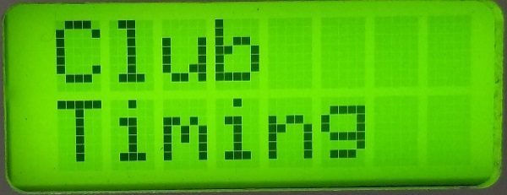

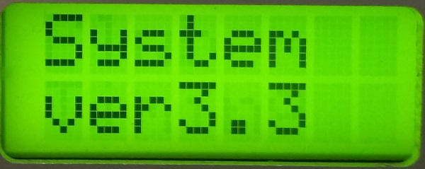

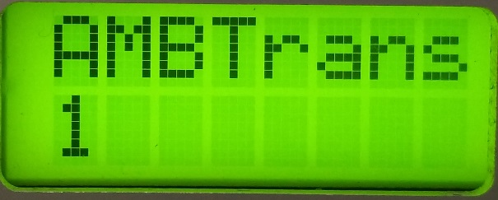

Decoder sends the average background noise every two seconds to the computer.
Noise level, as shown by the Track Timing software, should not exceed 20. If the noise level is higher, decoder may not fix transponders. If you have a high noise level, please use power from the battery. If noises remains, we recomend to connect decoder to the computer via Wifi interface or check where is source of noises.

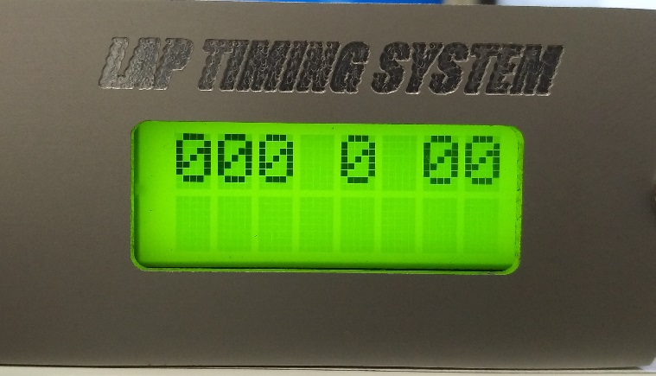

Noise level
Fixed signal level

Fixed transponders count (during one interval ~3 sec ))

Status display
When you connect decoder via USB cable, PC will find it and install necessary drivers. Please wait up to 10 minutes. If PC automatically can not find drivers on Internet, please use drivers from attached CD/USB key.

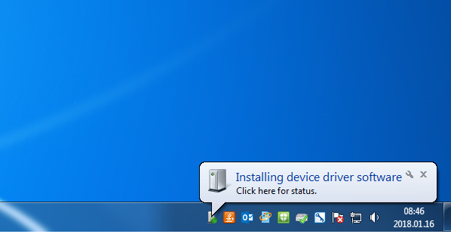

After drivers installed, you can see USB Serial Port number.

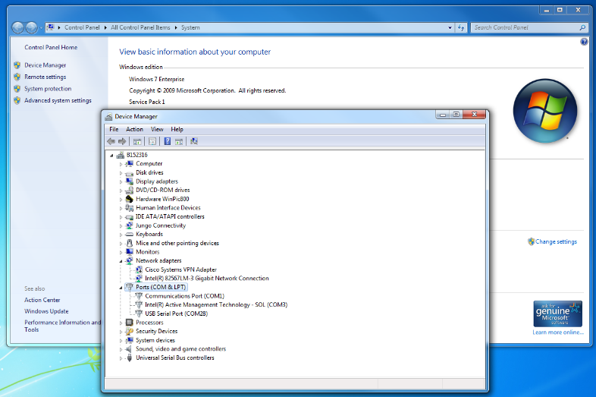

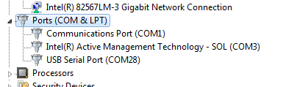

When decoder is istalled, it sends „hello“ packets to PC. You can use PuTTY or other terminal programm to see this. Lap timing system works fine with Laps free, RCM and other software.

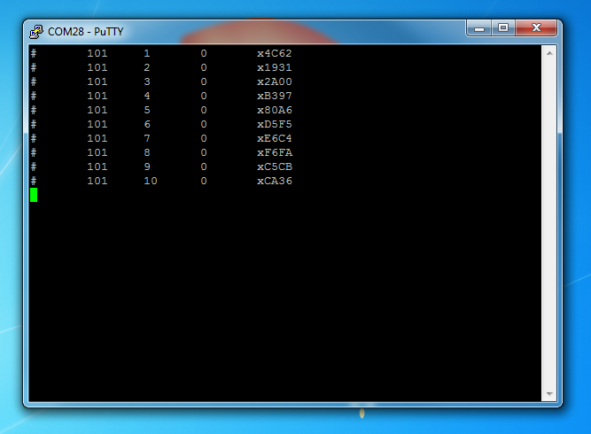

Terminal view (you can use PuTTY or another terminal program)

If installed comport is higher than COM8, please change this comport to lower:

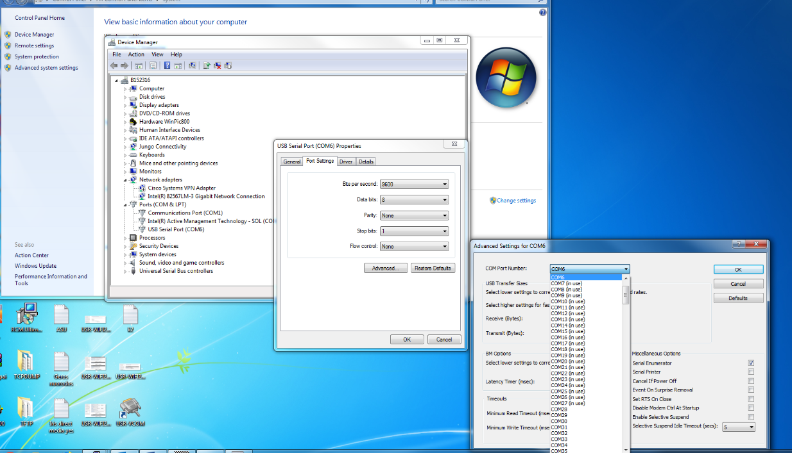

Important!!! When you use RCM, Laps free and other software, you must note this is AMBrc decoder connected via Serial port on configuration of these programs.

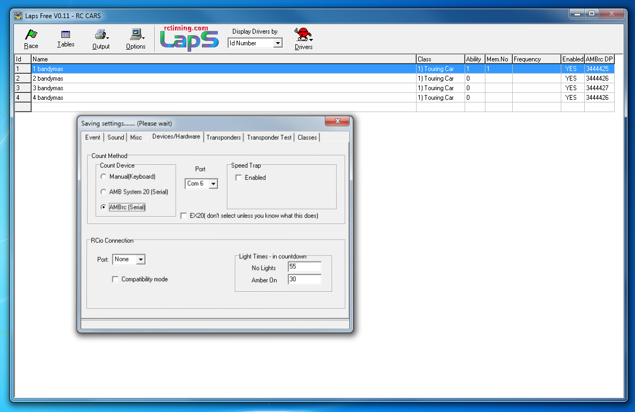

Number of hits and interference

The number of hits, as shown by Timing software, is an indication of number of repeated contacts during a passing. Hit - rate varies with the speed of a passing transponder. Slower passings yield higher hit counts.
Interference (noise), indicated on LCD screen, can severely reduce the number of hits per passing. Most interference is caused by (modified) speed controllers of RC model cars, battery chargers/power supplies any electrical switch in the area or, usually at night, by short - wave radio stations. Electronic equipment may also cause interference. Switch off the suspected equipment to find out.
Peaks in background noise level can be caused by any electrical switch in the area or, usually at night, by short -wave radio stations. Electronic equipment may also cause an increased background noise level. Switch off the suspected equipment to determine if this is the cause. Ignitions of engines may also be a source of interference which only shows when the vehicle without a transponder passes the detection loop.
If the noise level is increased and fluctuates strongly, your detection loop may be cut or broken, or have an electrical connection to ground. The loop may still detect transponders, but there will be some degradation of the system’s performance.
The system is especially sensitive to interference with bad connections in the detection loop or coax cable. Typically, when connections in the detection loop are not soldered and mounted with heat shrinkage sleeves or when BNC connectors are not properly fitted, interference is picked up more easily. The fluctuation in noise level will be more noticeable in wet conditions since water acts as a conductor and will give a better connection to ground.
• If the signal strength is fluctuating heavily in combination with high noise levels, the loop wires may be cut.
• If the signal strength of the same car is fluctuating heavily with a normal noise level, this usually indicates that the coax cable or BNC connector short - circuits occasionally.
• If the coax cable is permanently short - circuited (core and shielding touching each other), the signal strength and hit count will always be low with a normal noise level. Measure the coax cable ( must be 100 kOhm) and try replacing the BNC connector first. If the problem persists, try a new coax cable.

How can I prevent unwanted signal reception?

The shielding of the coax cable prevents unwanted signals from being received by the decoder. Although shielded, a transponder signal is strong enough to penetrate the shielding and is detected on the coax cable itself. Especially when coax cable needs to be routed through the pit lane, this can cause phantom transponder inputs. Therefore, the coax cables are best routed through a metal cable duct. The metal surrounding the cable duct will act as a shielding itself and will therefore prevent transponders from being detected on the coax cable.

Possible causes of high background noise levels:

- When the detection loop is damaged, a fluctuation in noise level will be noticeable, especially in wet conditions. If this is the case, please check the loop wire and coaxial for cuts or breakage.
- Electrical equipment too close (<3 m) to the loop or coaxial cable.
- Using a generator with a poor ground connection.
- Use of DC/AC converter for AC power.
- Poor connections between the detection loop and the coaxial cable.
- BNC connector incorrectly fitted to the coaxial cable.
- Poor ground connection of the AC power. If this is the case, ground the decoder by connecting the outside of the BNC connectors on the decoder to a piece of metal (copper rod or tube) that is in a fixed connection with the ground.

Problems
Most problems are due to bad connections or improper installation, usually the cabling, lay-out or position of the pick-up loop. To check the coax cable: use Ohmmeter to measure Ohms between center pin and outer metal the of BNC connector. It should read 95 kOhm to 105 kOhm. Also, the red wires into the connection box can be measured: it should read 95 kOhm to 105 kOhm (470 Ohm resistor disconnected). Mobile phones and other forms of personal radio communications do not affect Timing systems.

A few transponders are not being detected

If this is the case, the problem is most likely related to the individual transponder or the positioning of the transponder.
Check the mounting position of the transponder, for more information check your transponder manual.

None of the transponders are being detected

If this is the case, the problem is most likely related to the detection loop, decoder, timing computer or cabling. Please take the following steps:
Check if a beep is heard in the headphone, or if the LED blinks during a transponder passing. If this works, but nothing appears on the computer screen, check the cabling between decoder and computer.

If you still have questions or remarks, please contact us by e-mail: vostokelectronics@gmail.com

4. Technical Specifications

Dimensions : 212x117x32mm
Weight : 0.4 kg
Timebase Resolution : 0.01s
Temperature range : 0 - 50C / 32 - 122F
Humidity range : 10% to 90% relative
Operating voltage range: 7 to 12VDC (12VDC input)
Power consumption : 0.5-1A via 12VDC input, 0.5-1A via USB
Output : RS232, 9600 baud, 8 bit, 1 stop-bit, no parity
USB, FastEthernet, Wifi 2.4GHz b/g/n
Number of loops : 1
Max. track width : 2x10m=20m, when use for boats with especially amplifier: max. 2x18m =36m
Audio output: 3,5mm for Headphones
Compatible with : MRT, AMB DP, MyLaps RC3, MyLaps RC4 hybrid, Our, and others transponders who use the same coding. Not compatible with MyLaps RC4 transponders.

5. Menu options explanation

In front of decoder you will find an information display designed to view and change decoder settings. The status screen will show the following information:
- Signal strenght
- Noise level
- Last detected transponder ID
- Detected transponders count during one cycle

Also in menu you can find:
- Firmware version
- Known transponders database
- Uptime
- Edit/Reset/Send transponders database

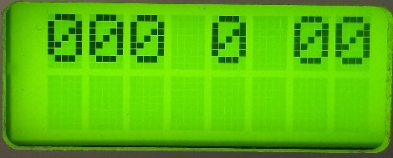

Status display

Menu tree:

STATUS DISPLAY

UPDATE FIRMWARE

RESET CODES

DELETE CODES

SEND RECORDS

SESSION UPTIME

KNOWN AMB compatible / CLUB tranponders count

Explanations:

Status display – this is main display, after loop detects crossing transponders, display indicates signal strenght, noise level, detected transponders count (during one cycle). Detecting cycle is about 3 seconds. This decoder is not locked for one manufacturer, decoder can read multiple transponders, and „valid“ is any compatible transponder ID, which repeats 3 and more times during one cycle.

Firmware upgrade – device isn’t locked and you can change firmware any time. If you want to change firmware, you must press „Firmware upgrade“ button and while keeping it pressed push the power switch on. Runs bootloader and you can easily change your firmware.

Reset codes – for faster recognition, decoder stores all known transponders ID. If you want to clear all known ID or flash memory is full, you can reset all codes. After that the equipment must be reloaded, and device will memorise all codes again. After this action device and timing software must be reloaded.

Delete codes – you can delete unnecessary ID one by one. After corrections device and timing software must be reloaded.

Send records – you can send all information about known transponders ID to terminal (use PuTTy or other terminal program to see). After this action device and timing software must be reloaded.

Session uptime – uptime from power up in seconds.

Known AMB compatible / CLUB transponders counts.

6. Physical configuration explanation

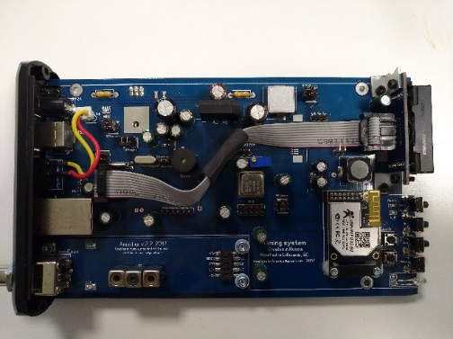

Decoder has an opportunity to change some options:

- Enable/disable power directly from USB
- Enable/disable Wifi power for energy saving
- Enable/disable buzzer beep
- Enable/disable data transmit over USB/Serial/Wifi/Ethernet interfaces
- Serial interface internal pinout
- Wifi module factory reset/reload options
- FastEthernet module serial emergency configuration (using AT commands. Please follow manufacturer instructions from another PDF file).

Please contact to manufacturer before you buy timing system and we will configure device on your requests.

Important!!! We strongly do not recomend to power the device, when case is opened/PCB unscrewed from aluminum case. If you want power on the device without casing - never use power from external power source, when case is open. Use only power from USB source, this prevent power stabiliser from overheating and burn! Always disable USB and power plugs, when you disassembling decoder, or if decoder is partially opened/disassembled.

For decoder disassembling you will need:

- Screwdriver „+“
- 2mm Hex tool
- 8mm x 2pcs nutdriver
- Pliers
- Antistatic bracelet

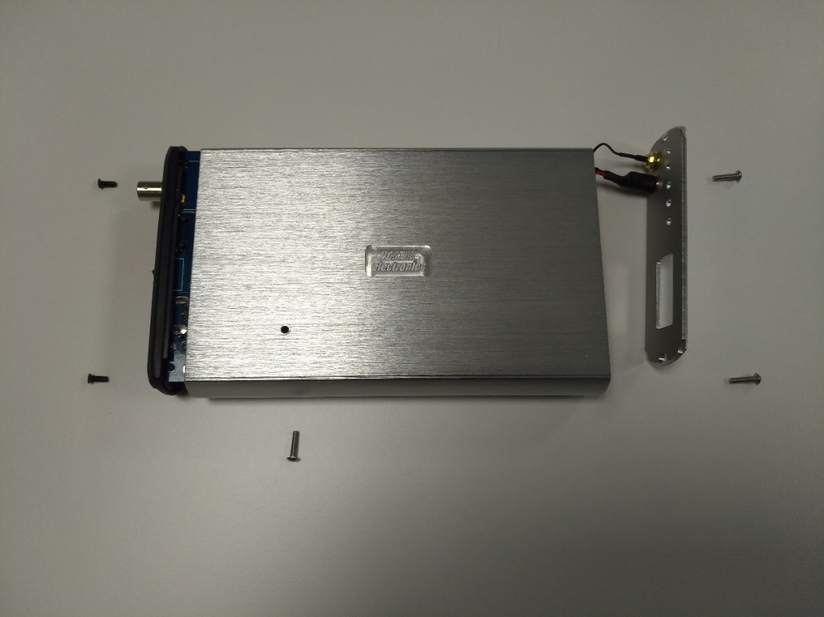
3
2

1
Decoder unscrewing order

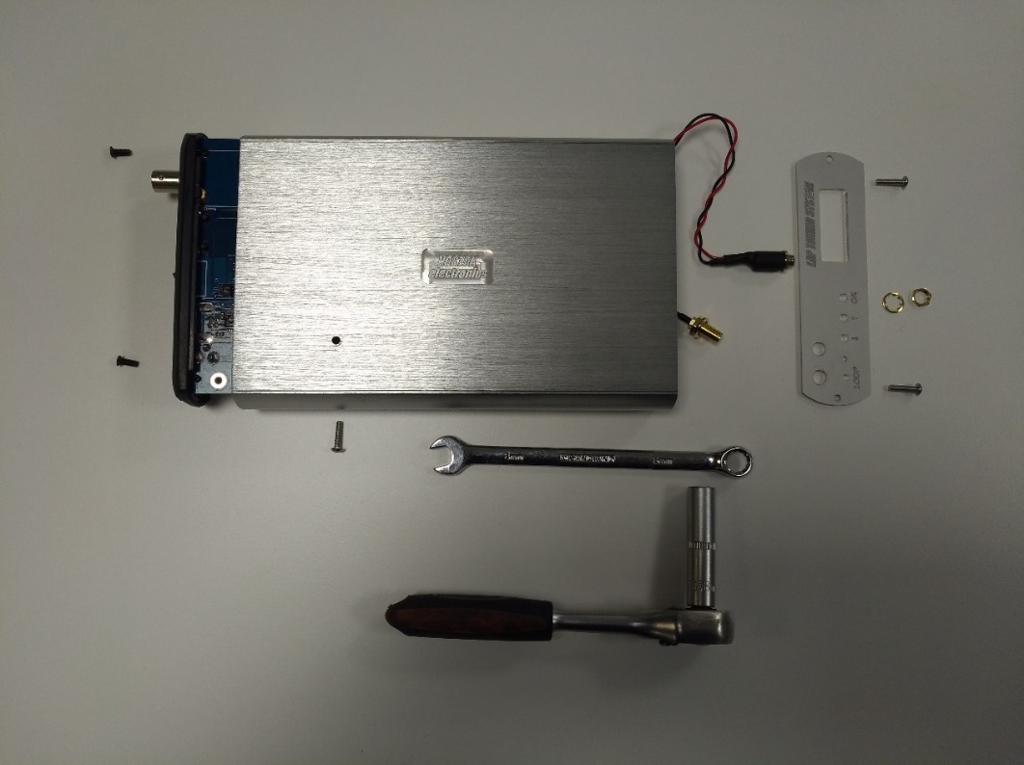

Unscrewing audio and Wifi antenna outputs

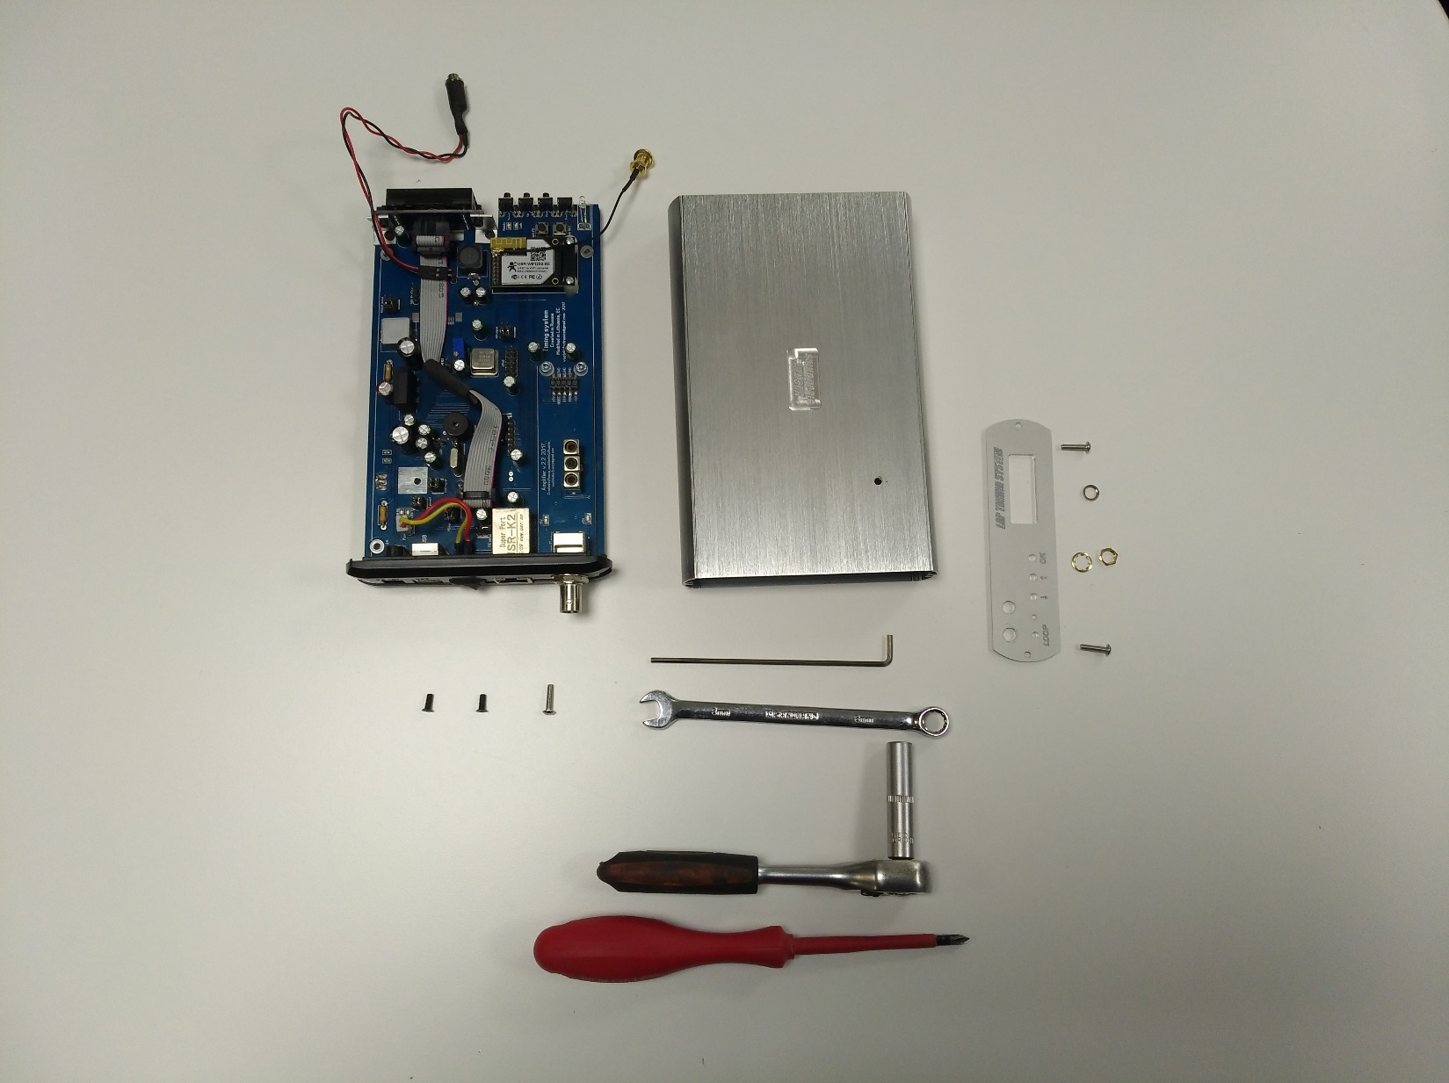

Fully disassembled decoder unit and tools for this work.

Disassembling, changing options and assembling usually takes about 10minutes. Please assemble in reverse order.

Options change

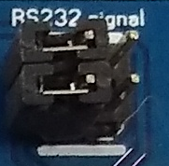

Important!!! If you want to change settings yourself, be sure to keep the link in the direction of the indicated lines. Otherwise, the equipment will be damaged.

7. FastEthernet and port configuration

If you use Ethernet interface to connect decoder and PC via LAN, you must use Virtual Comport software. This software you can find at attached CD/USB key.

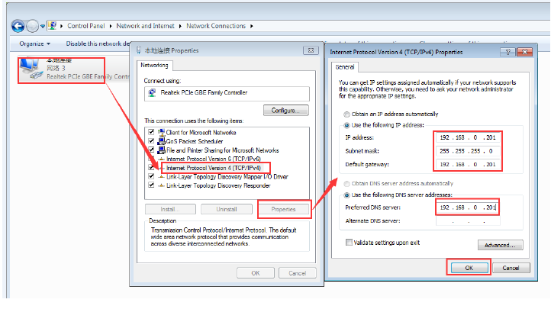

Default parameter list

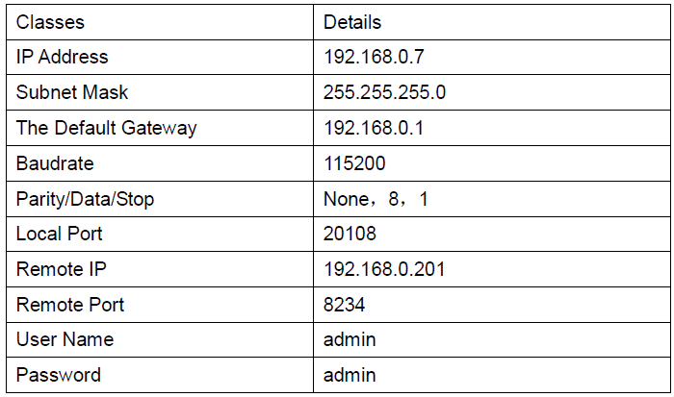

Open a browser, type and Login above IP address http://192.168.0.7, you wil enter module‘s setup webpages. There will be a windows login verify dialog.
User name and password are both „admin“, this can be modified after login into the system.
After login you can see webpage as follow:

- Local IP Config: the module's ip address, submask and gateway parameter
- RS232: the module's serial to ethernet parameter
- Web to Serial: web to serial data transparent
- Misc Config: some parameters such as user name and password parameter
- Reboot: user can reboot/restart module from here

Configuration from Web Page

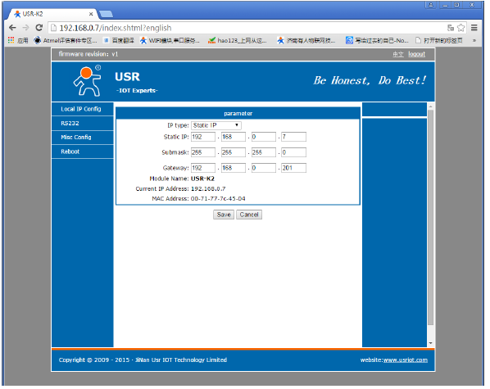
IP adress, Mask, Gateway settings page

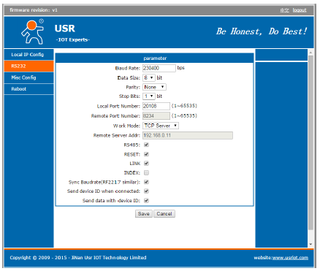
RS232 settings page

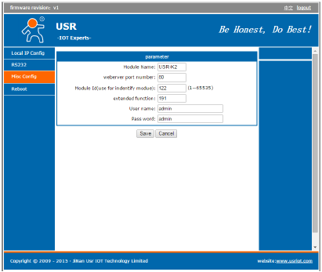
Miscellaneous settings page

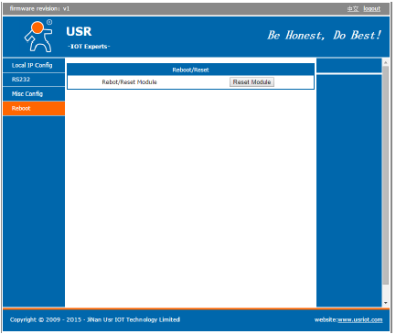
Reboot page

If you have misconfiguration and can not acces to configuration webpage, please use emergency cable.
Full instructions and information about AT commands you can find on attached PDF file on CD/USB key.

8. Wifi interface module

Decoders Wifi module support of 802.11 b/g/n protocols, which provide a wireless interface to any equipment with a Serial interface for data transfer.
The module used to MAC, baseband chip, RF transceiver unit, as well as the power amplifier; embedded firmware support wi-fi protocols and configuration, as well as the network TCP/IP protocol stack.
Wifi as a hot spot can accommodate 32 clients simultaneously wi-fi access, but also can accommodate 32 TCP client.

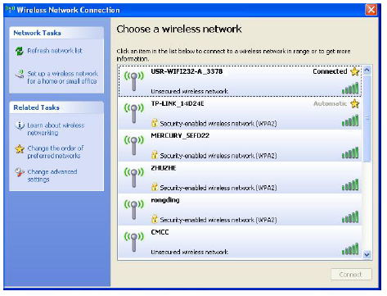
Wifi search

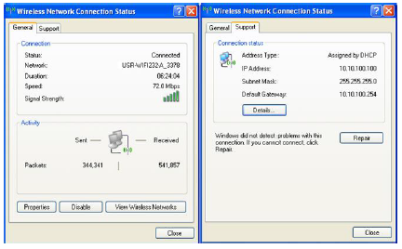
Join the network, choose automatically obtain IP,
Wifi module supports DHCP server feature and is enabled by default

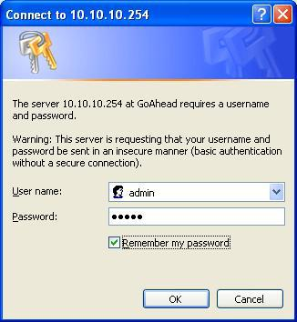

Enter login and password

Module default‘s settings:

- SSID: Vostok timing system
- Encryption mode: open, none
- UART: 57600/9600,8,1,none
- Network parameters: TCP, Server, 8899, 10.10.100.254

Quick configure page

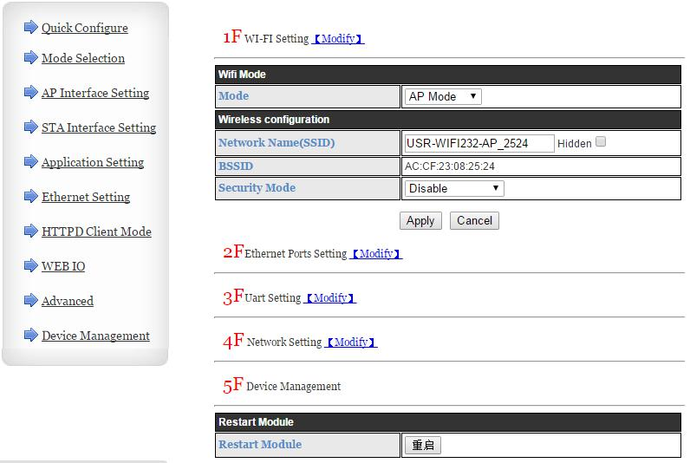

This page has four configuration options and a restart, the corresponding instructions below:
- WI-FI Setting: set the working mode of wifi, AP mode or the STA.
- Ethernet Ports Setting: open/close the Ethernet ports, and set up the corresponding work
mode.
- UART Setting: set serial port parameters, including baud rate, parity bit, 485 functions and so
on.
- Network Setting: set network parameters, Only TCPA related parameters.
- Device Management: when after completion of the above parameters are configured, click
reset module.

Mode selection page

This page used to adjust the wireless networking mode (AP and STA mode). "Data transmission mode" selection module working mode are "Transparent Mode", "Serial Command mode", "HTTPD Client mode", "GPIO mode". "TCP connection password authentication" can choose whether open TCP password authentication.

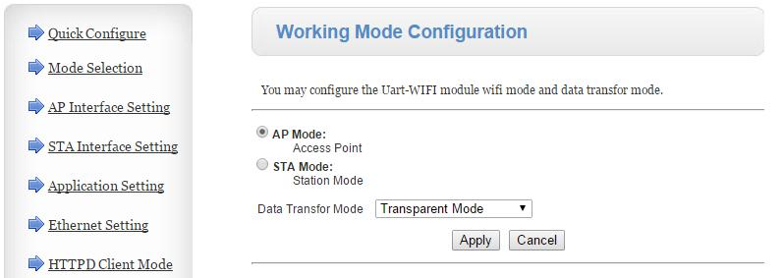

AP Interface Setting Page

This page used to set the parameters when USR-WIFI232-A/B/C module works as AP.

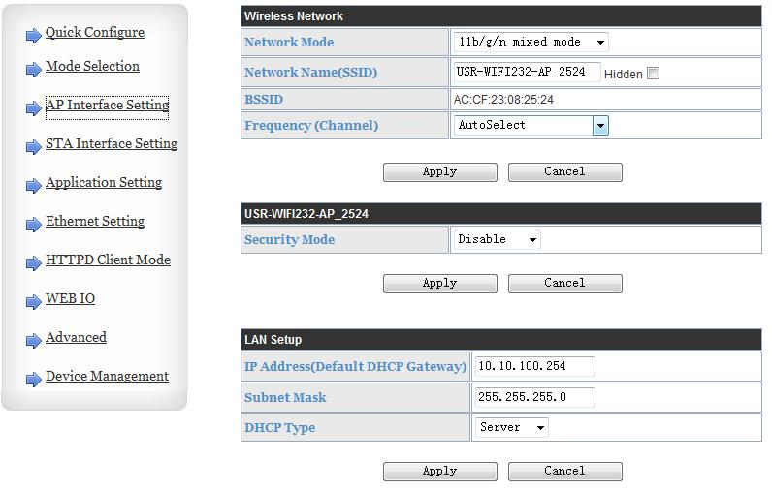

STA Interface Setting Page

This page used to setting the parameters when USR-WIFI232-B2 module works as STA. Such as SSID of AP which module need to connected, and also select the networking type: DHCP or static IP address.

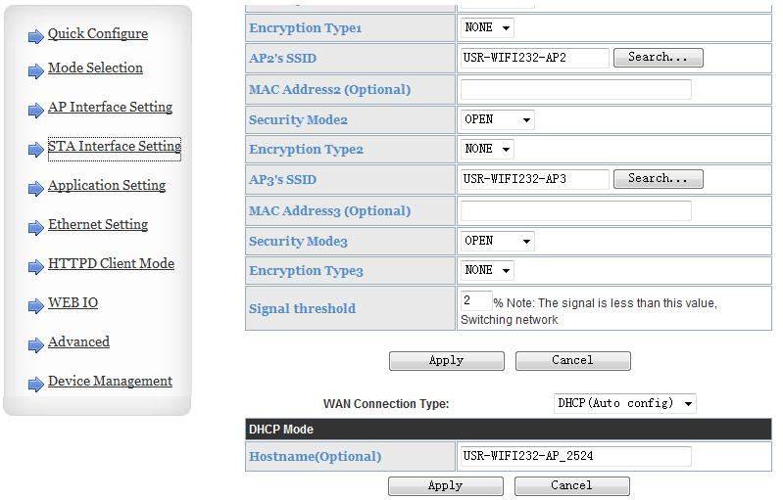

Application Setting Page

This page used to set the parameters of serial port communication, such as UART setting,UART AutoFrame Setting, Ethernet function, Device ID setting and high layer network protocol setting which used support serial communication.

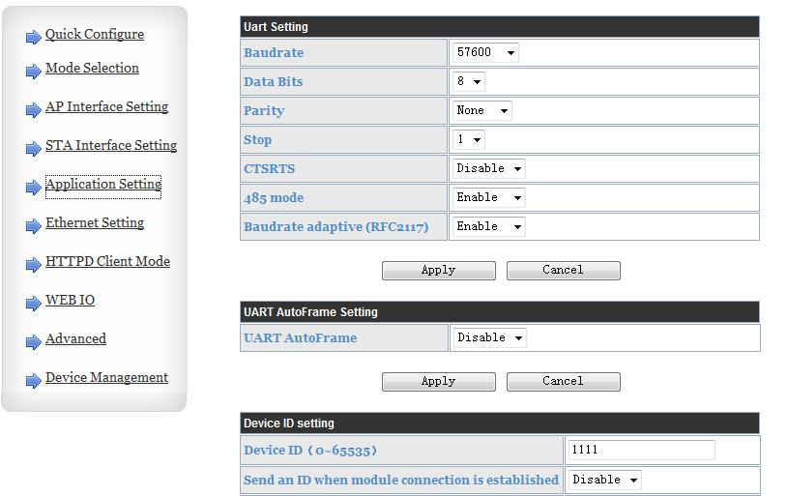

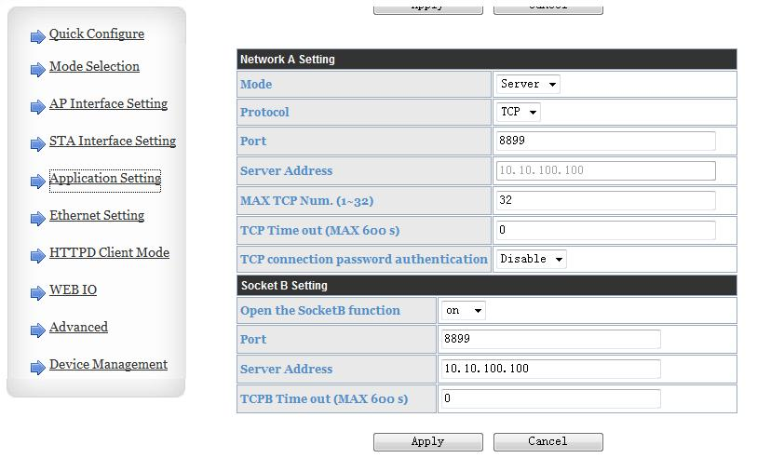

Notes:
Generally, Network protocols support three modes: TCP Server, TCP Client, UDP Client,UDP
Server.

Besides module working as TCP Server (IP address not required in this mode). User must set the
IP address of the device which need to communicate with USR-WIFI232-B2 module.
Also the Port ID between two sides of the communication devices must kept the same.

HTTPD Client Mode

This page sets the HTTP header in the HTTPD Client mode. Include: the address of the server, the server port, request type, protocol header path, Connection, user-agent. HTTPD Client mode support POST, PUT, GET three HTTP request types.Is a POST or PUT request way, serial data can be added to the back of the HTTP header;When the request is a GET, data can be added to the back of the path in the HTTP header.

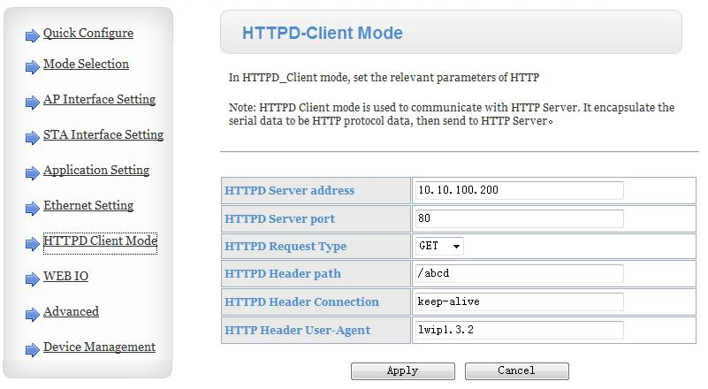

Device Management Page

This page use to manage USR-WIFI232-A/B/C module general setting, such as administrator setting,
restart module button, restore factory default setting button, and update firmware through webpage.

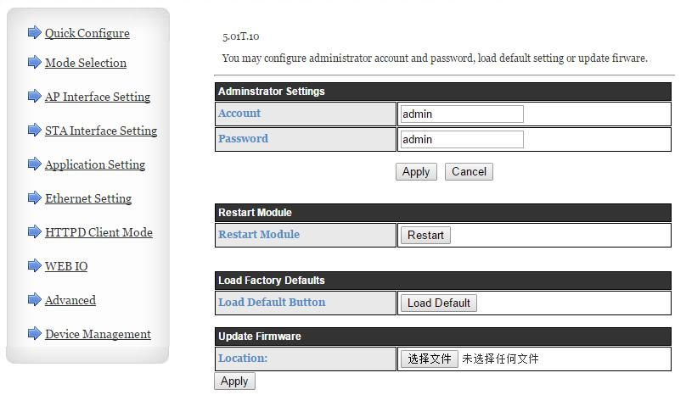

Notes: Restart module button: When you setting the parameters of different web pages, you will click “Apply” button to confirm the setting, but the setting take effect only after user click the “Restart” button here, the module will re-boot up and refresh the memory information with new changes.

AT command Introduction

Configuration Mode
When USR-WIFI232-B2 power up, it will work by default as transparent transmission mode, then user can switch to configuration mode by serial port command. USR-WIFI232-B2 UART default parameters setting as below figure.

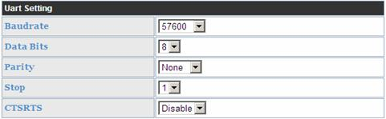

In configuration mode, user can set the module through AT+ instruction set, which cover all
web page setting function.

Full instructions and information about AT commands you can find on attached PDF file on CD/USB key.

9. Virtual COM Mode

Virtual COM means to convent data TCP connected to data of a COM within PC for transparent transmission.
You must use this software for decoder connections during Ethernet or Wifi interfaces.

Installation process will follow:

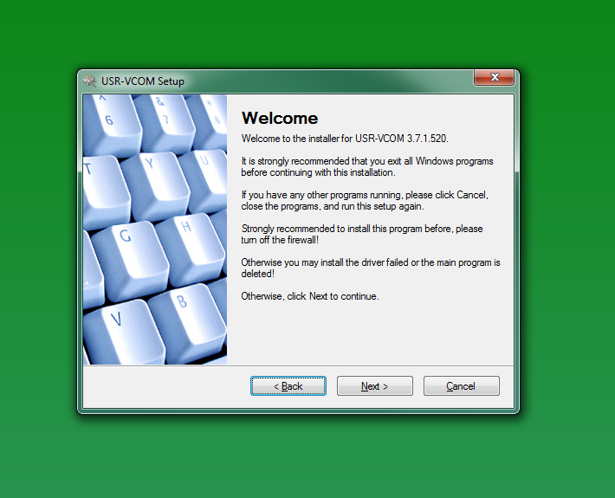

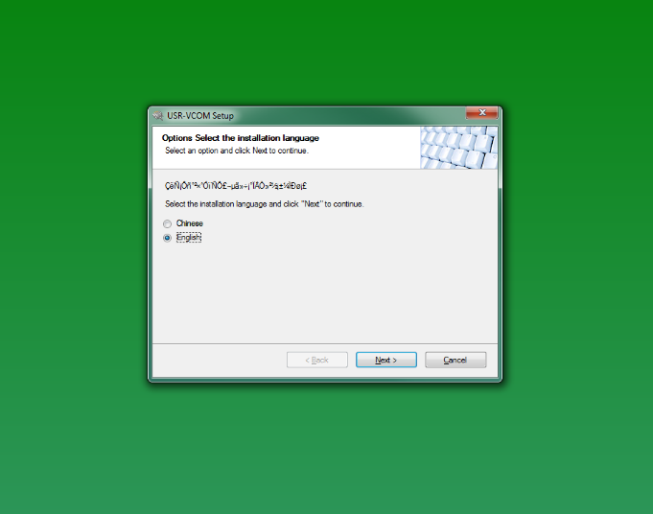

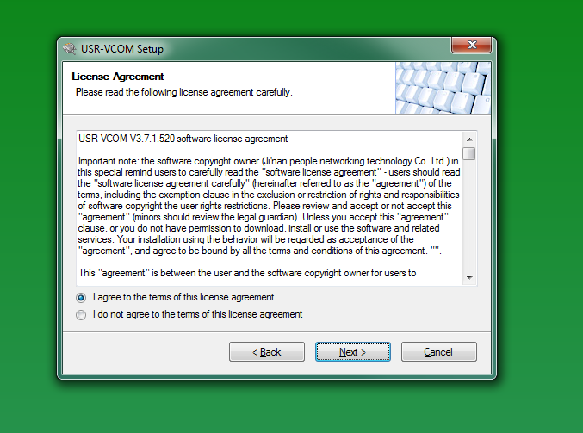

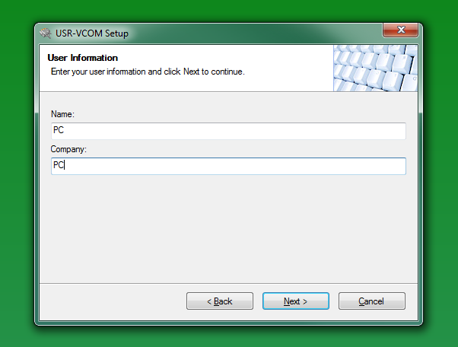

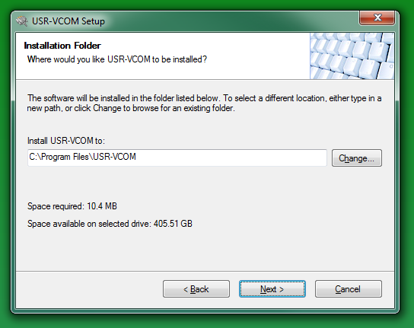

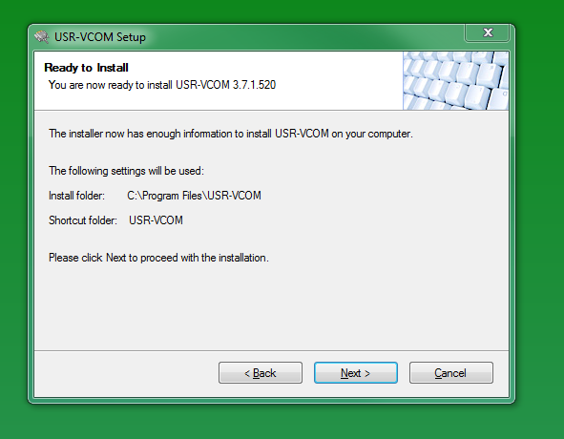

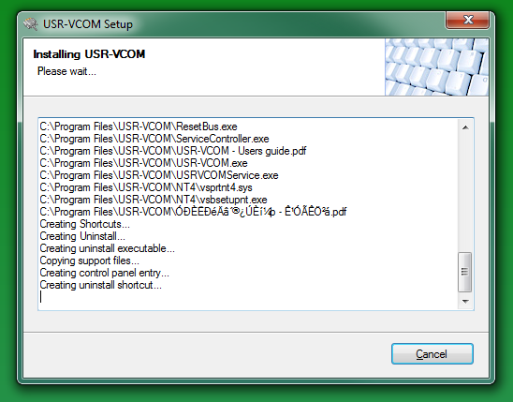

You must install Eltima software:
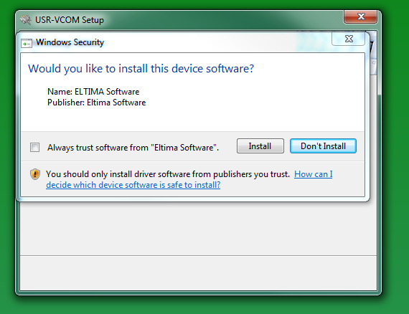

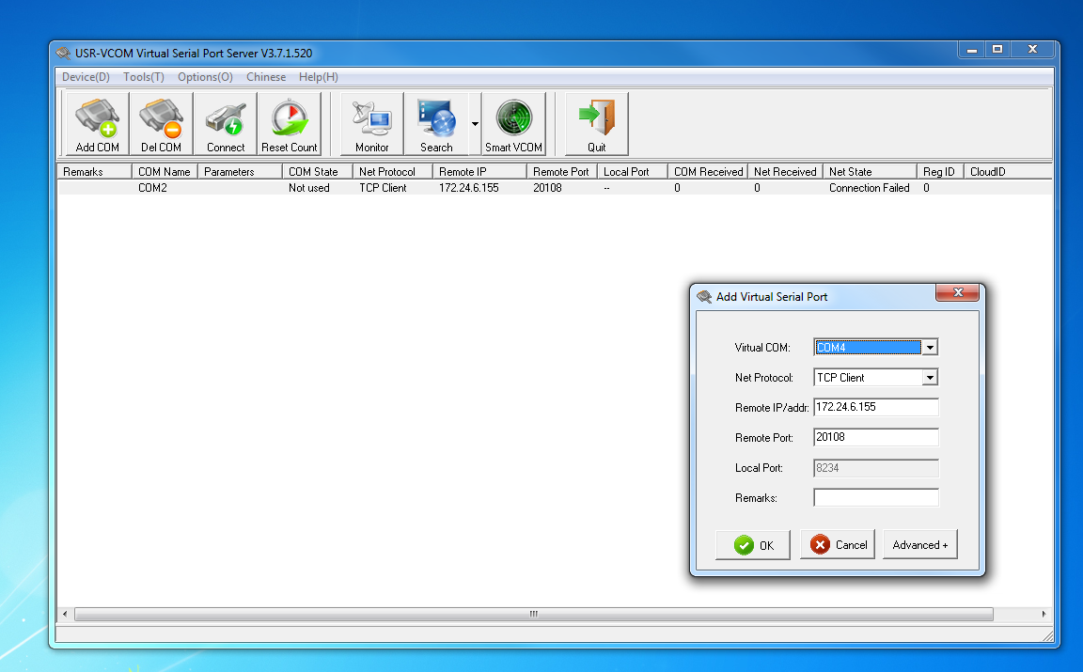

Take TCP Client mode for example:

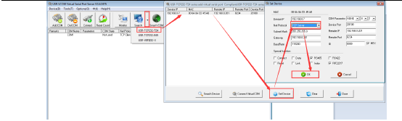

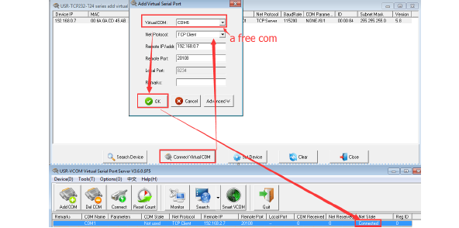

10. Guarantiees

We guarantee that any items manufactured by us are fully tested and working well. As you have free access to PCB, change and tune any options we can’t give you any warranty. If Lap Timing System burns out or faults, we can repair this equipment for reasonable price. Our goal is not to double profit from the client. If you have any questions, please contact us. In period of 1 year from selling the system, we can offer you to buy a new device for a special price if it is not possible to repair.

Contact us by e-mail: vostokelectronics@gmail.com

